

USER MANUAL FOR THE CANAL THE COMPLIANCE CHANEL
SANLUCAR FRUIT, S.L.U.

May 2024

INDEX
INTRODUCTION 2
WHAT IS MEANT BY AN INTERNAL INFORMATION CHANNEL? 2
WHEN SHOULD IT BE USED? 2
HOW DO WE PROCESS THE DATA AND WHO CAN ACCESS THE INFORMATION? 3
HOW LONG DO WE KEEP THE DATA? 3
HOW CAN WE ACCESS THE COMPLIANCE CHANNEL? 4
WHAT DO WE DO WHEN WE RECEIVE A COMMUNICATION? 4
WHAT IS THE DIFFERENCE BETWEEN AN ALERT AND A CONSULTATION? 5

INTRODUCTION
The internal reporting channel is an obligation for companies to comply with the provisions of Law 2/2023, of 20 February, regulating the protection of persons who report regulatory infringements and the fight against corruption.
The implementation of an internal information channel in an organisation means complying with one of the basic tools that make up an organisational and management model referred to in our legislative system.
This channel must offer both the whistleblower and the reported person guarantees of confidentiality and anonymity, as well as a secure means of communication, access and storage of information, and generation of evidence. Whistleblowing channels or ethical channels are considered to be the most effective control measure among the anti-fraud and anti-corruption prevention mechanisms.

WHAT IS MEANT BY AN INTERNAL INFORMATION CHANNEL?
The Internal Information Channel is the means through which employees, managers, members of the SANLUCAR FRUIT administrative body and any third party with whom the company has a relationship (suppliers, clients, external consultants, etc.) can inform the Head of the Internal Information System of any irregular conduct that is contrary to our internal or external regulations, or that may involve a criminal offence.
The SANLUCAR FRUIT Channel aims to guarantee coexistence and a good working environment in the company, which is vital for the development and growth of the entity.
Legitimised by the fulfilment of a legal obligation and a mission carried out in the public interest, such as the protection of legal assets, as well as our legitimate interest in avoiding conduct that may involve criminal liability for the company, SANLUCAR FRUIT has an Internal Information Channel through the corresponding web form with the aim of communicating all conduct that may constitute a crime.

WHEN SHOULD IT BE USED?
It must be used in those situations in which there is knowledge of a conduct or fact that may constitute a serious criminal or administrative offence, breach of company regulations and any other illegal activity that contravenes the interests of SANLUCAR FRUIT.
The purpose of this User Manual is to encourage all employees to use the tool in good faith and to ensure that the communication is based on facts or indications from which it can reasonably be inferred that the aforementioned conduct has taken place. The communication of false information should therefore be avoided.
The Channel is not the appropriate medium to discuss issues related to your terms and conditions of employment. In this case, you should follow the policies established in your organisation. If any of these issues are received, they will be immediately filed by the SANLUCAR FRUIT Internal Information System Manager.

HOW DO WE PROCESS THE DATA AND WHO CAN ACCESS THE INFORMATION?
The Channel will collect the data through a form, even anonymously.
The confidentiality of the informant's data (e-mail) is ensured by keeping it anonymous unless its identification is a necessary and proportionate obligation imposed by EU or national law in the context of an investigation carried out by national authorities or in the framework of judicial proceedings, in which case it must be communicated to the authorities competent in the matter.
As the data is anonymous for the Head of the Internal Information System, the design of the application itself prevents any type of reprisal against the alerter.
In any case, the data of the data subjects shall remain confidential and shall be processed in accordance with the applicable data protection regulations.

HOW LONG DO WE KEEP THE DATA?
All information that may serve as evidence of the conduct or facts that are the subject of the communication must be retained for as long as there is a legal obligation to retain such documents.
In any case, the provisions of the Internal Information System Policy shall be complied with, thus, the information shall be kept for the time necessary to decide whether to initiate an investigation into the facts.
In any case, after 3 months have elapsed from receipt of the communication without any investigation having been initiated, the communication must be deleted, unless the purpose of storage is to leave evidence of the operation of the system. Communications that have not been followed up may only be recorded in anonymised form, without the obligation to block them provided for in the LOPD being applicable. Information relating to reports that have been followed up and are in the process of being investigated will be retained for as long as it is relevant to the process for the commission of offences outside the channel.

HOW CAN WE ACCESS THE COMPLIANCE CHANNEL?
Through different links you can access the Compliance Channel enabled for each of the SANLUCAR Group companies:
MAMARITZ SLU: Click here to access the Compliance Channel.
THE ROETZER FAMILY SLU: Click here to access the Compliance Channel.
SANLUCAR FRUIT SLU: Click here to access the Compliance Channel.
AGRICOLA DEHESA DE BAÑOS SL: Click here to access the Compliance Channel.
SANLUCAR CANARIAS SLU: Click here to access the Compliance Channel.
UNIQUA FRUIT SL: Click here to access the Compliance Channel.
NATURE ORIGIN FRUIT SLU: Click here to access the Compliance Channel.
GRUPO FRUTAS AQUA SL: Click here to access the Compliance Channel.
EL PUNTAL AGRARIA SA: Click here to access the Compliance Channel.
AGRICOLA PONY SL: Click here to access the Compliance Channel.
From this link, you will access a platform of an external provider in order to ensure anonymity and data protection of the informant, the reported person and those named in the communication.
Through the platform, you can complete a form in which you can register, if you complete it, the email address you use to receive notification of the receipt of the communication and its subsequent resolution informing you of the actions taken by the Organisation. In no case will the third party provider or the organisation be aware of this email address, as all notifications will be contained within the platform.
In the form you will be able to provide the information you consider and upload all those files that are configured as evidence of the reported facts.
Once you have completed the form, you will receive notification of receipt and a tracking number for the communication.
Within a maximum period of 3 months, through the same mechanism, you will receive a notification that will include the resolution issued by SANLUCAR FRUIT and you will be informed of the actions taken.

WHAT DO WE DO WHEN WE RECEIVE A COMMUNICATION?
Once the communication has been received, the Head of the Internal Information System will proceed to analyse the facts in order to determine whether to proceed to file the proceedings or to open an investigation into the facts that have been reported.
When deemed necessary, the person in charge, as the person responsible for ordering the initiation of the investigation, may request additional information or evidence through the same tool, in order to confirm the necessary details and proceed to open the corresponding investigation file.
The details of the persons concerned shall never be disclosed in the communication when it could lead to a conflict of interest with the System Manager or the Entity's management.
In the event that the information communicated could be directed against the person acting as Head of the Internal Information System, or against some of the members of the collegiate body in charge of managing the Compliance Channel, it would be necessary to identify such person through the form, stating their name and surname and e-mail address: jorge.peris@sanlucar.com, amparo.marquez@sanlucar.com; izaskun.gracia@sanlucar.com, in the space on the form indicated below in order to prevent access to it:
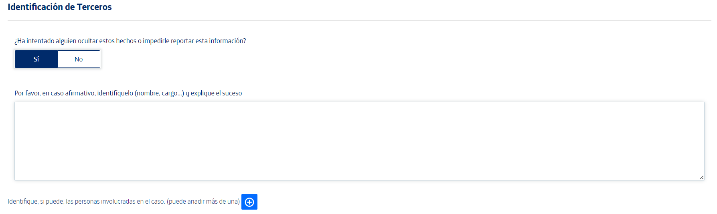

The Head, as well as all members of the collegiate body in charge of managing the Compliance Channel, are obliged to maintain the confidentiality of all information to which they may have access as a result of the communication made.
Finally, the supplier in charge of the maintenance of the channel will periodically verify the correct functioning of the tool.

WHAT IS THE DIFFERENCE BETWEEN ALERT AND CONSULTATION?
Through the alert, you, as an informant, will be able to report any issue that you consider to be a serious administrative or criminal offence.
Through the consultation, you can ask any question about the functioning of the channel, anti-retaliation measures or deadlines within which your alert will be resolved, as well as any other question that may arise or originate from the use of the Channel.
Under no circumstances may it be used for the submission of queries other than the internal information system itself.

